Project Design Phase

Solution Architecture

Date | 2o February 2026
Team ID | LTVIP2026TMIDS79198
Project Name | Resolve Now: Your Platform for Online Complaints
Maximum Marks | 4 Marks
Document Type | Solution Architecture
Solution Architecture:
Solution architecture is a structured process that bridges the gap between public issues and digital technology solutions. The project 'Resolve Now: Your Platform for Online Complaints' provides a centralized system where users can register complaints online and track their resolution status.
Its goals are to:
- Provide a secure and user-friendly complaint submission platform.
- Ensure proper storage and management of complaint records.
- Enable administrators to review, assign, and resolve complaints efficiently.
- Provide transparency by allowing users to track complaint status.
- Maintain data privacy, system security, and reliability.

Example - Solution Architecture Diagram:
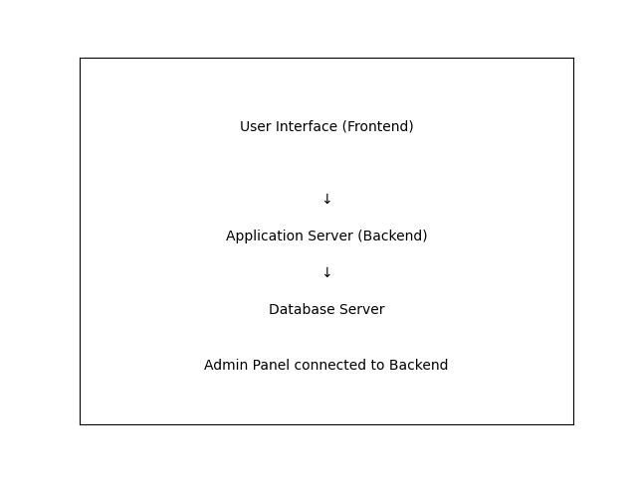
Figure 1: Architecture and data flow of the Resolve Now online complaint management system
Reference:
https://www.geeksforgeeks.org/system-design/complaint-management-system-design/

